1)

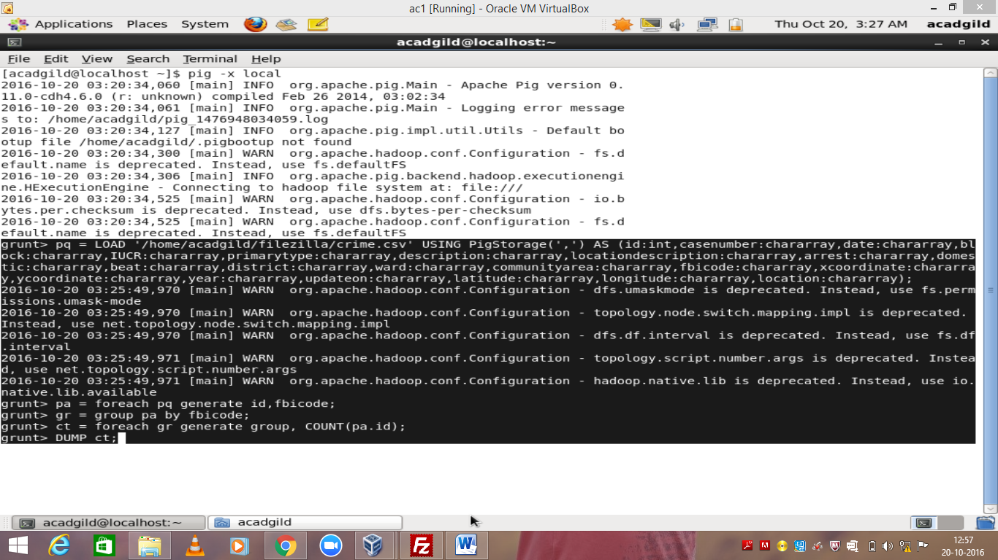

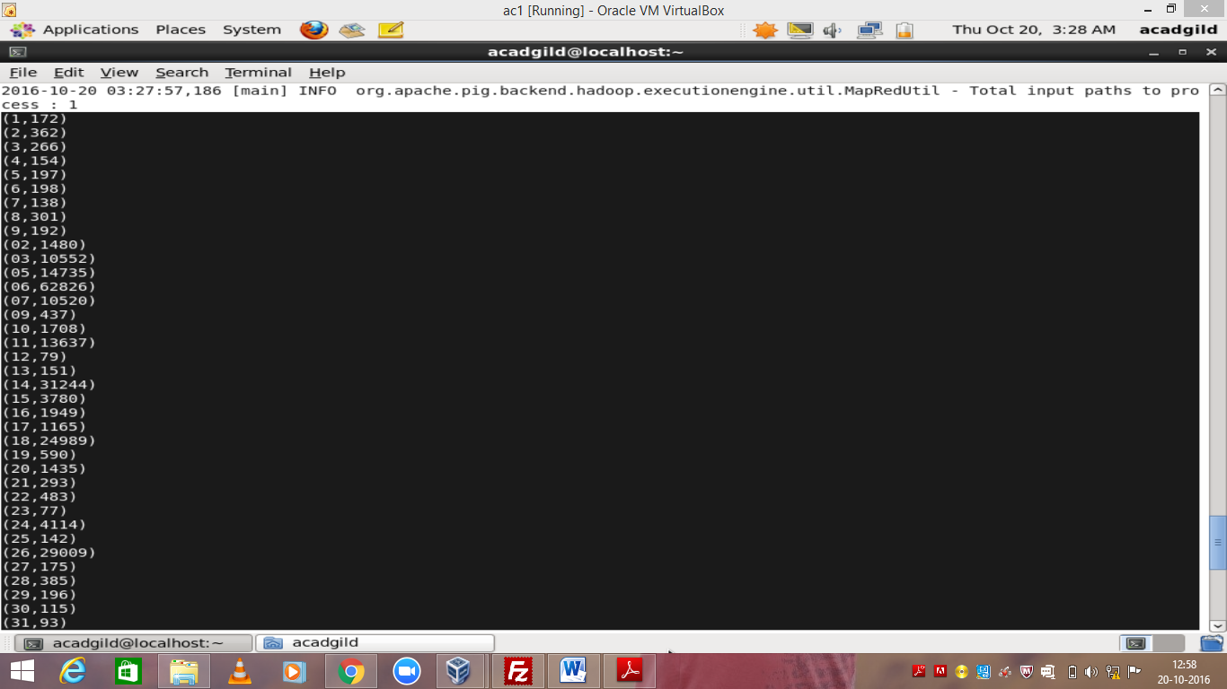

2)

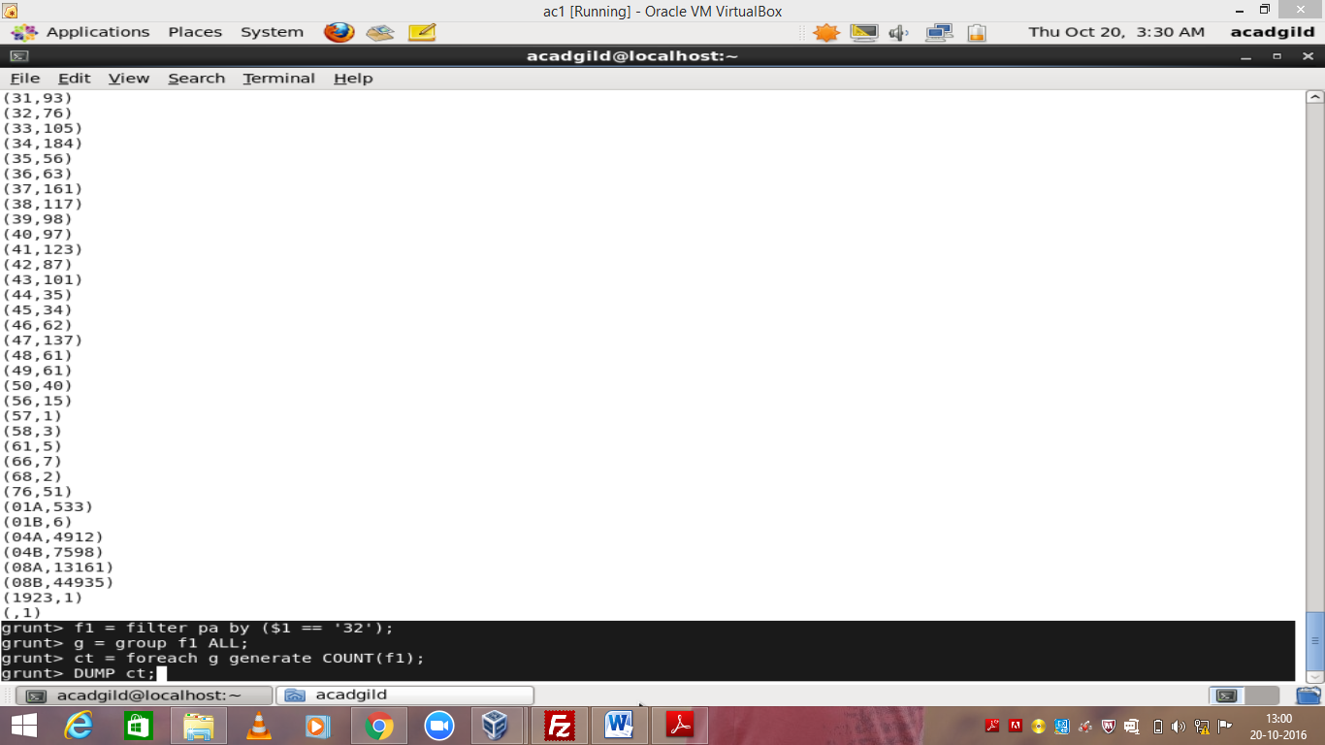

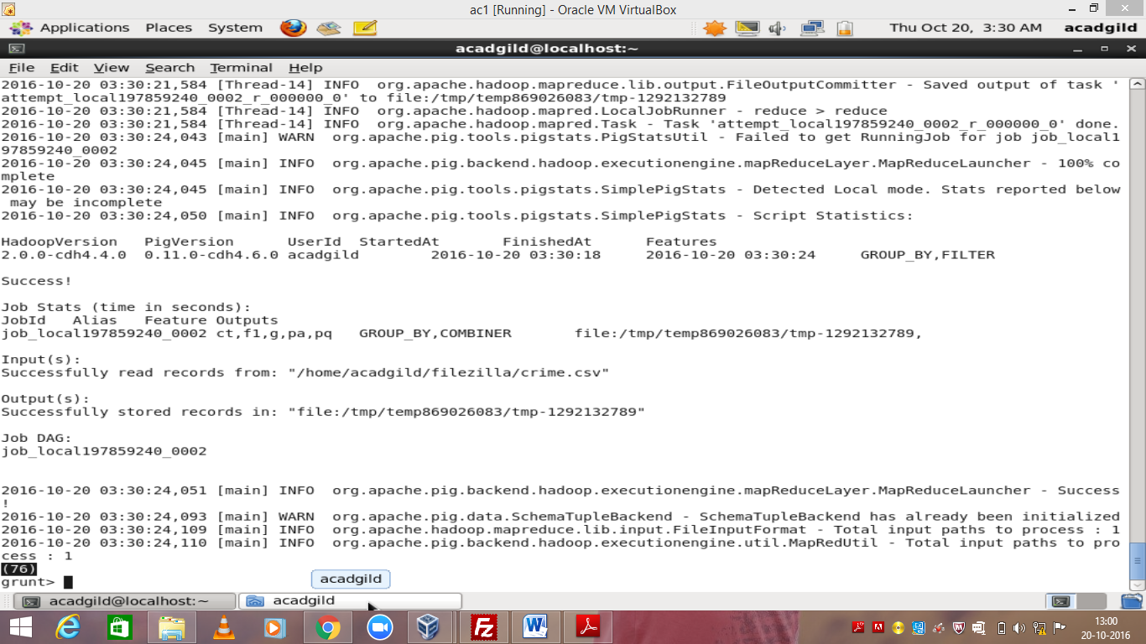

3)

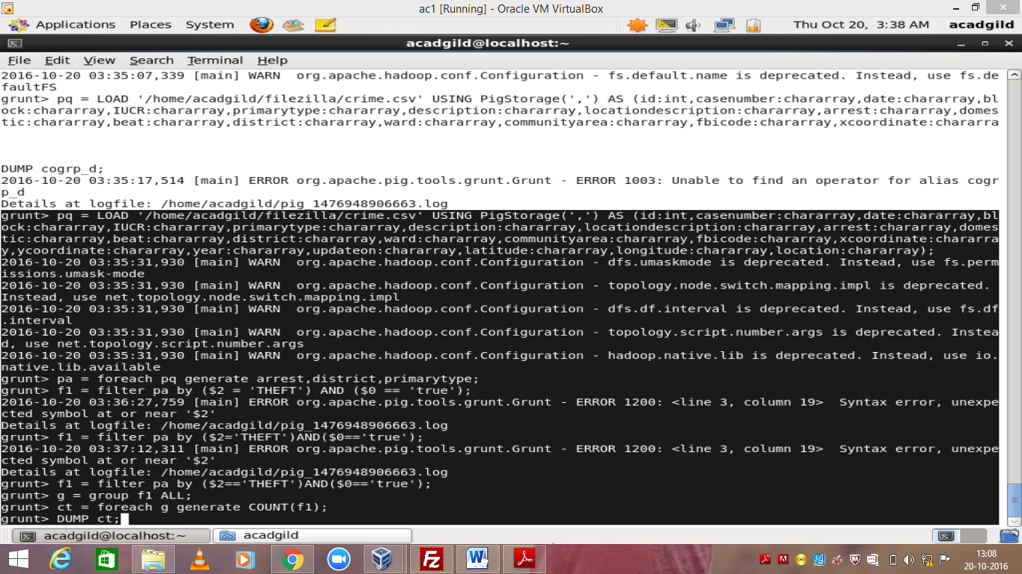

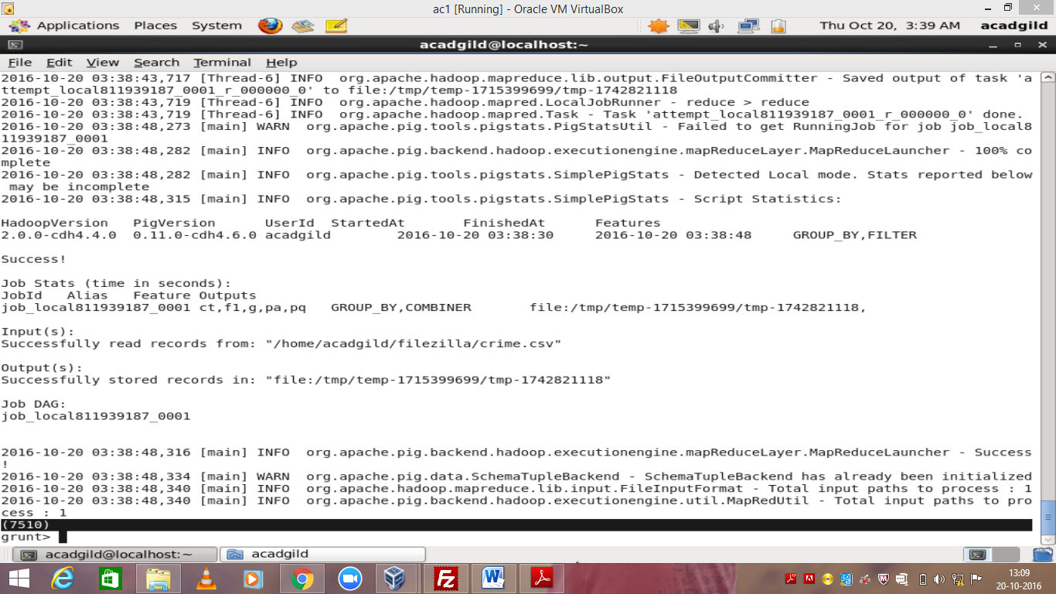

4)

1) pq = load ( );

2) **filter_arrest** = FILTER **pq** by arrest == 'TRUE';

3) **s_date** = FOREACH filter_arrest GENERATE update_on, arrest, SUBSTRING(update_on,0,2) AS month,                SUBSTRING(update_on,5,10) AS year;

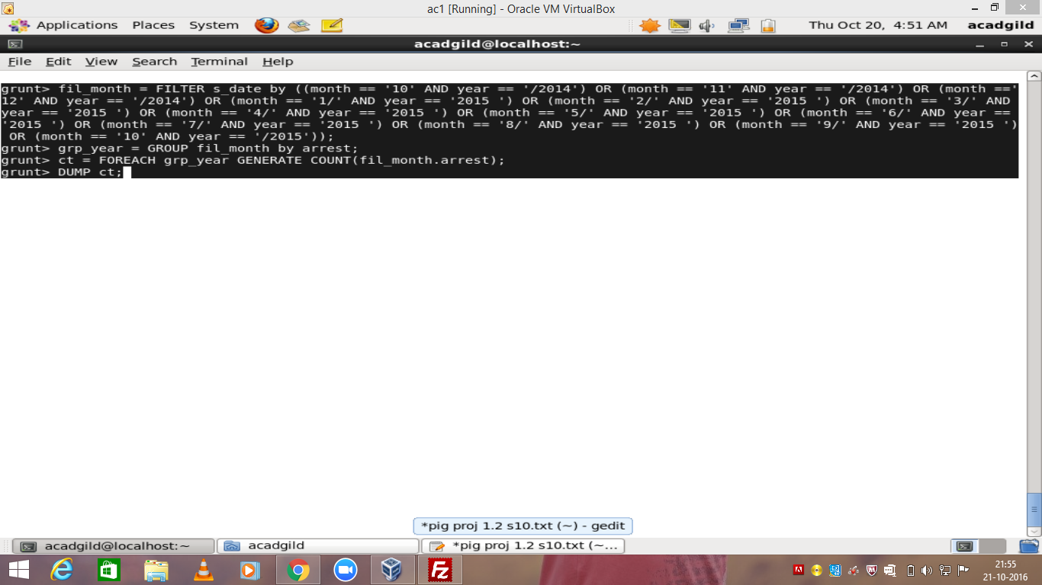

STORE ct INTO ‘/home/acadgild/crimeop’;

